Hello everyone!
Welcome to Year 1
I hope you have all had a lovely, fun-filled summer! We are so excited to welcome you to Year 1 and begin our new school year together in September!
This page is a little introduction to our Year 1 classroom and what you can expect when you arrive. Our Year 1 team includes Miss Fell, our class teacher, and Miss Boyce and Mrs Markham, our teaching assistants.
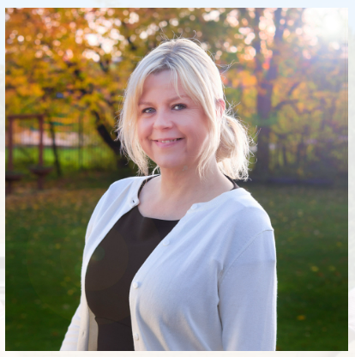
On this page, you will find some pictures of our classroom, as well as a timetable showing what a typical day in Year 1 might look like. Throughout the day, there will be short teaching inputs on the carpet, followed by opportunities for table work, independent learning and provision. Our provision will continue to be an important part of our day, giving children plenty of opportunities to explore, play, practise their skills and get busy with their learning!
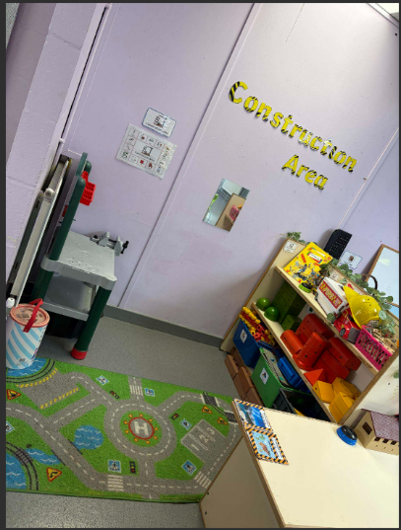
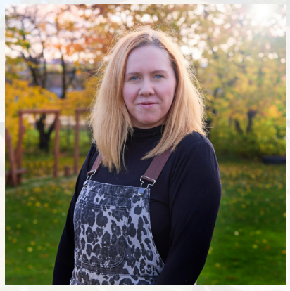

Provision areas
Teacher
Miss Fell
Teaching Assistant
Miss Boyce
Teaching Assistant
Mrs Markham

Construction Area
This is where the children can build, create and use their imaginations! They can explore different construction materials, make their own models and designs, and work together to create something amazing. The construction area also gives children opportunities to develop their problem-solving, creativity, communication and teamwork skills.

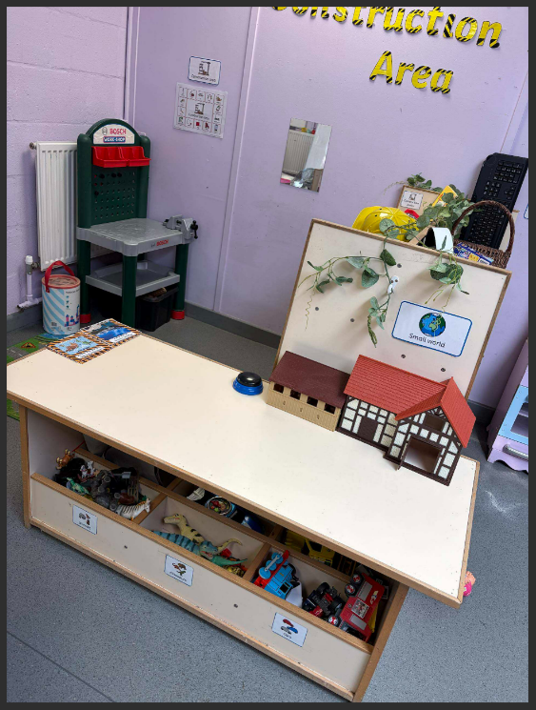
Small World Area
This is where the children can use their imaginations to create their own little worlds! They can explore different characters, settings and scenarios, create stories and act out different events. This area will also link closely to our writing tasks and the stories we explore in class, helping the children to develop their ideas, vocabulary and storytelling skills through play.
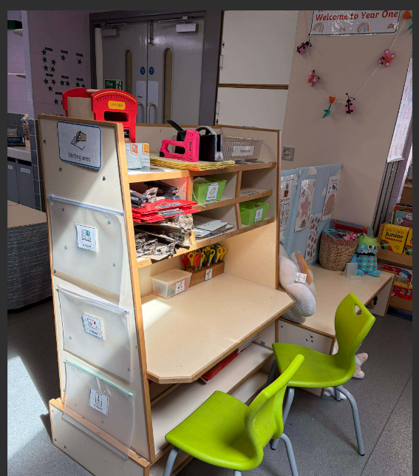
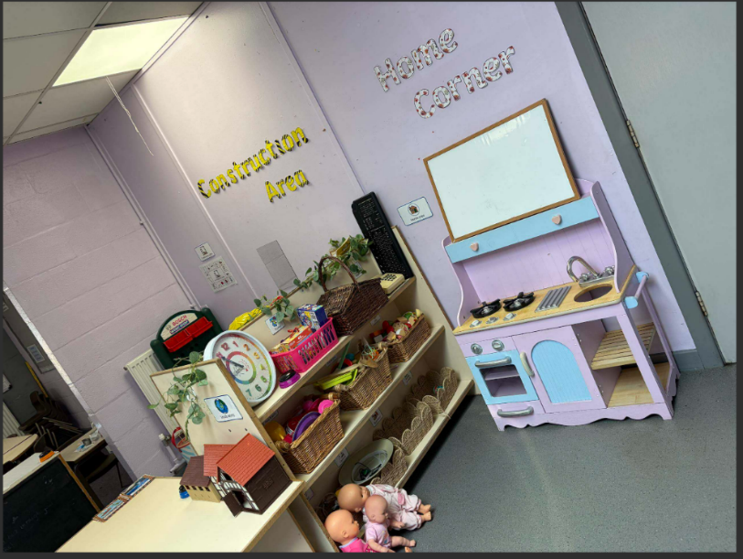
Writing Area
This is where the children can explore writing, practise their skills and develop their own ideas. They will have access to a range of writing resources and opportunities to write for different purposes. This area will link closely to our phonics, stories, topics and writing tasks, encouraging children to use the sounds and vocabulary they have learnt in their own writing.
Home Corner
This is where the children can use their imaginations, dress up and take on different roles through imaginative play. They can act out familiar experiences, create their own scenarios and bring stories to life with their friends. The Home Corner and dressing-up area will provide opportunities to develop language, communication, creativity, social skills and confidence, while also linking to our topics, stories and writing tasks in class.

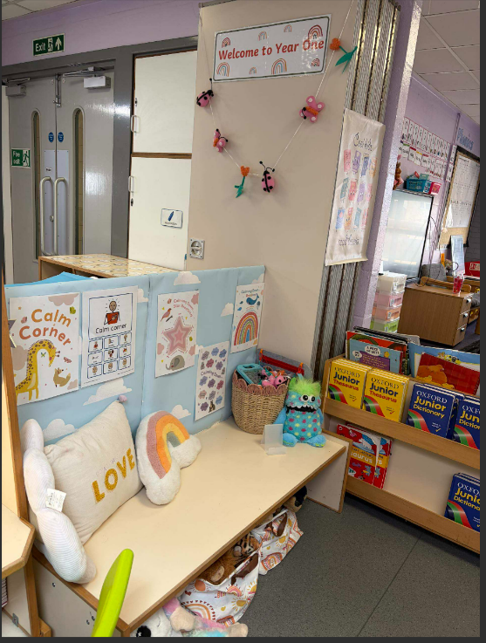
Calm Corner
This is where the children can take some quiet time for themselves if they need a little break from the busy classroom. We will use the Zones of Regulation to help children recognise and talk about how they are feeling and choose strategies that can help them feel ready to learn. The Calm Corner will provide a quiet space where children can relax, look at a book, practise calming strategies and have some time to themselves before returning to their learning.

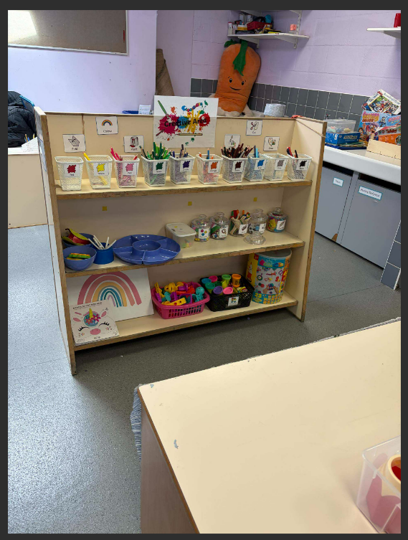
Creative Area
This is where the children can get creative, explore different materials and bring their ideas to life! They can draw, paint, cut, stick, make and experiment with a range of resources. The creative area will encourage children to use their imagination, develop their fine motor skills and express themselves through art and creativity. This area will also link to our topics, stories and learning in class.

Class Timetable

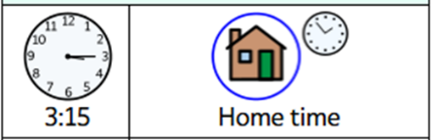
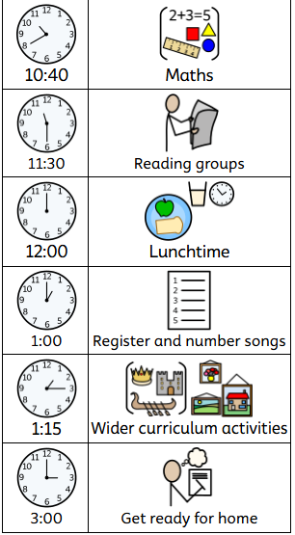
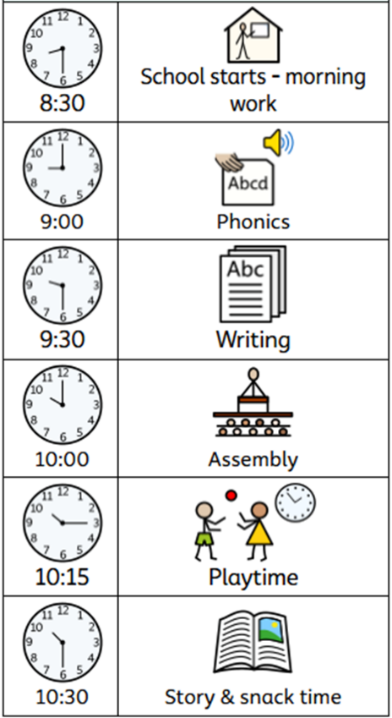
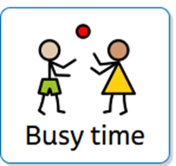

Busy time will be incorporated
throughout the day.
This will include:
- A construction area
- A home corner
- A creative area
- A reading/calm area
- Outside provision

